https://medium.com/analytics-vidhya/predicting-sales-time-series-analysis-forecasting-with-python-b81d3e8ff03f

Predicting Sales: Time Series Analysis & Forecasting with Python

[[](https://medium.com/@bismanpreetsingh?source=post_page-----b81d3e8ff03f--------------------------------)](https://medium.com/@bismanpreetsingh?source=post_page-----b81d3e8ff03f--------------------------------)

[Bisman Preet Singh](https://medium.com/@bismanpreetsingh?source=post_page-----b81d3e8ff03f--------------------------------)

Follow

[Jan 28, 2020](https://medium.com/analytics-vidhya/predicting-sales-time-series-analysis-forecasting-with-python-b81d3e8ff03f?source=post_page-----b81d3e8ff03f--------------------------------) · 15 min read

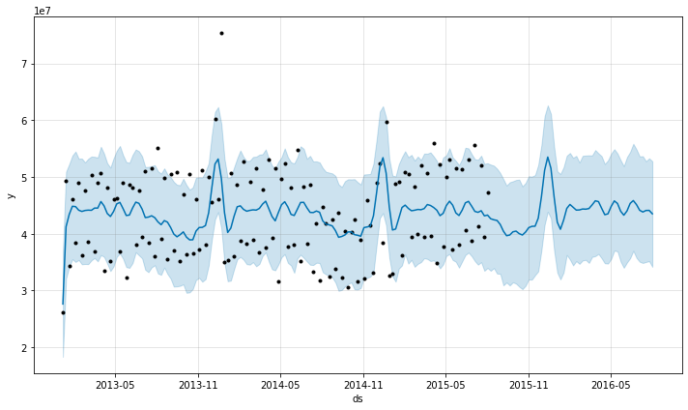

One of the most important tasks for any retail store company is to analyze the performance of its stores. The main challenge faced by any retail store is predicting in advance the sales and inventory required at each store to avoid over-stocking and under-stocking. This helps the business to provide the best customer experience and avoid getting into losses, thus ensuring the store is sustainable for operation.

In this post, I’ll use Rossmann store [data](https://www.kaggle.com/c/rossmann-store-sales) available on Kaggle.





Rossmann operates over 3,000 drug stores in 7 European countries. The challenge is to predict their daily sales for up to six weeks in advance. Store sales are influenced by many factors, including promotions, competition, school and state holidays, seasonality, and locality.

This post is divided into two parts: EDA & Forecasting

**Part A) Exploratory Data Analysis (EDA)**

Let’s start by first importing the required libraries followed by data exploration.

# Importing required libraries  
import numpy as np  
import pandas as pd, datetime  
import seaborn as sns  
from statsmodels.tsa.stattools import adfuller  
import matplotlib.pyplot as plt  
get_ipython().run_line_magic('matplotlib', 'inline')  
from time import time  
import os  
from math import sqrt  
from statsmodels.tsa.seasonal import seasonal_decompose  
from statsmodels.graphics.tsaplots import plot_acf, plot_pacf  
import itertools  
import statsmodels.api as sm  
from statsmodels.tsa.stattools import acf,pacf  
from statsmodels.tsa.arima_model import ARIMA  
from sklearn import model_selection  
from sklearn.metrics import mean_squared_error, r2_score  
from pandas import DataFrame  
import xgboost as xgb  
from fbprophet import Prophet  
import warnings  
warnings.filterwarnings('ignore')# Importing store data  
store = pd.read_csv('./data/store.csv')  
store.head()



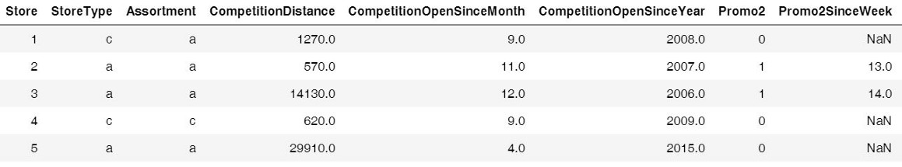

The above table gives us information about 1115 stores owned by Rossman.

# Importing train data  
train = pd.read_csv('./data/train.csv', index_col='Date', parse_dates = True)  
train.head()



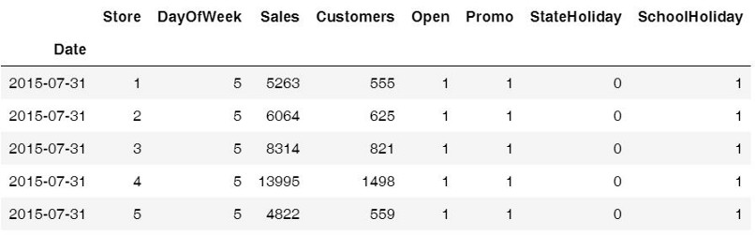

We can see from the above table that the date is one of the columns. What makes this analysis unique is that ‘Date’ is one of the important factors influencing sales and it acts as an independent variable. To put it simply, this is a time-series data i.e a series of data points ordered in time.

1. **Trends & Seasonality**

Let’s see how the sales vary with month, promo, promo2 (second promotional offer) and year.

# Sales trend over the months and year  
sns.factorplot(data = train_store_joined, x ="Month", y = "Sales",   
 col = 'Promo', # per store type in cols  
 hue = 'Promo2',  
 row = "Year")



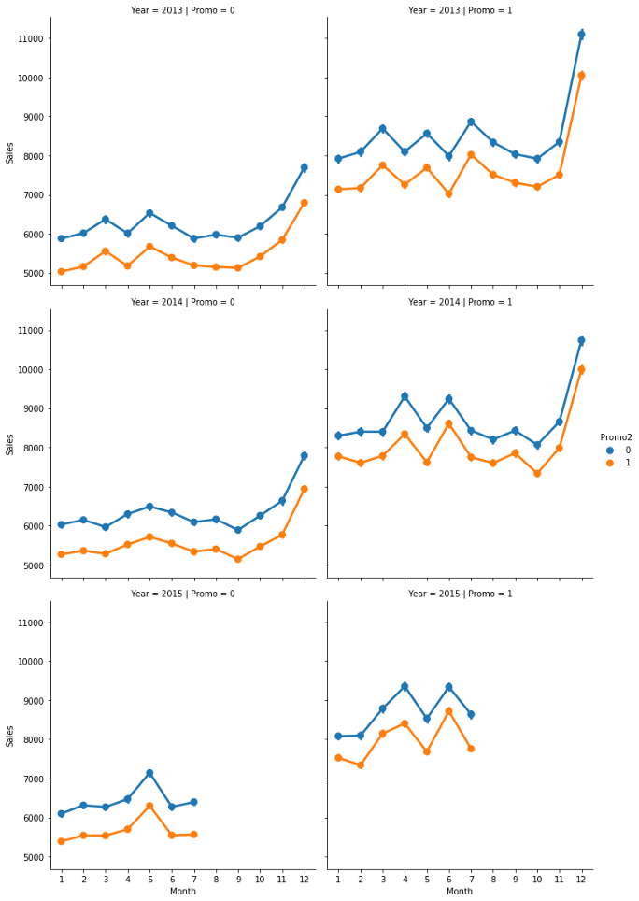

The above graph tells us that sales tend to spike in December, which makes sense because of the Christmas and holiday season. So, this confirms that the sales vary with the ‘Date’ (time) and there is a seasonality factor present in our data.

# Sales trend over days  
sns.factorplot(data = train_store_joined, x = "DayOfWeek", y = "Sales", hue = "Promo")



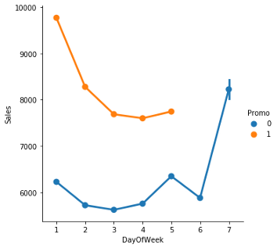

We can see from the above trend that there are no promotions on the weekends i.e Saturday and Sunday, which makes sense as stores want to earn a maximum profit during the time when people do their house chores.

The sales tend to increase on Sunday because people shop during the weekend. We can also see that the maximum sale happens on Mondays when there are promotional offers.

**2. Stationarity of Time Series**

In order to use time series forecasting models, we need to ensure that our time series data is stationary i.e constant mean, constant variance and constant covariance with time.

There are 2 ways to test the stationarity of time series:

**a) Rolling Mean**: A rolling analysis of a time series model is often used to assess the model’s stability over time. The window is rolled (slid across the data) on a weekly basis, in which the average is taken on a weekly basis. Rolling Statistics is a visualization test, where we can compare the original data with the rolled data and check if the data is stationary or not.

**b) Dicky -Fuller test**: This test provides us the statistical data such as p-value to understand whether we can reject the null hypothesis. The null hypothesis is that data is not stationary and the alternative hypothesis says that data is stationary. If the p-value is less than the critical value (say 0.5), we will reject the null hypothesis and say that data is stationary.

Let’s check the stationarity of a store of type ‘a’.

# Data Preparation: input should be float type  
train['Sales'] = train['Sales'] * 1.0# Assigning one store from each category  
sales_a = train[train.Store == 2]['Sales']# Trend  
sales_a.resample('W').sum().plot(ax = ax1)



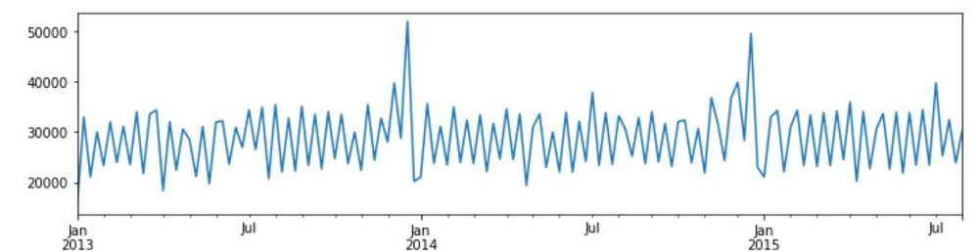

The above graph tells us that sales tend to peak at the end of the year.

# Function to test the stationarity  
def test_stationarity(timeseries):  
   
 # Determing rolling statistics  
 roll_mean = timeseries.rolling(window=7).mean()  
 roll_std = timeseries.rolling(window=7).std()# Plotting rolling statistics:  
 orig = plt.plot(timeseries.resample('W').mean(), color='blue',label='Original')  
 mean = plt.plot(roll_mean.resample('W').mean(), color='red', label='Rolling Mean')  
 std = plt.plot(roll_std.resample('W').mean(), color='green', label = 'Rolling Std')  
 plt.legend(loc='best')  
 plt.show(block=False)  
   
 # Performing Dickey-Fuller test:  
 print('Results of Dickey-Fuller Test:')  
 result = adfuller(timeseries, autolag='AIC')  
 print('ADF Statistic: %f' % result[0])  
 print('p-value: %f' % result[1])  
 print('Critical Values:')  
 for key, value in result[4].items():  
 print(key, value)# Testing stationarity of store type a  
test_stationarity(sales_a)



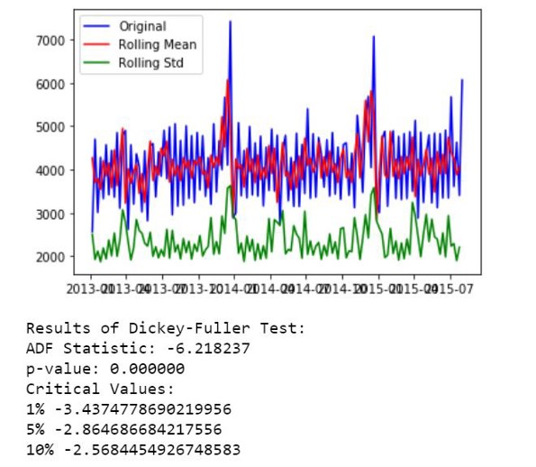

We can see from the above plot and statistical test that mean and variation doesn’t change much with time, i.e they are constant. Thus, we don’t need to perform any transformation (needed when time series is not stationary).

Now, let’s see the seasonality and trend using decomposition plots.

# Plotting seasonality and trend  
def plot_timeseries(sales,StoreType):fig, axes = plt.subplots(2, 1, sharex=True, sharey=False)  
 fig.set_figheight(10)  
 fig.set_figwidth(15)decomposition= seasonal_decompose(sales, model = 'additive',freq=365)estimated_trend = decomposition.trend  
 estimated_seasonal = decomposition.seasonal  
 estimated_residual = decomposition.resid  
   
 axes[1].plot(estimated_seasonal, 'g', label='Seasonality')  
 axes[1].legend(loc='upper left');  
   
 axes[0].plot(estimated_trend, label='Trend')  
 axes[0].legend(loc='upper left');plt.title('Decomposition Plots')



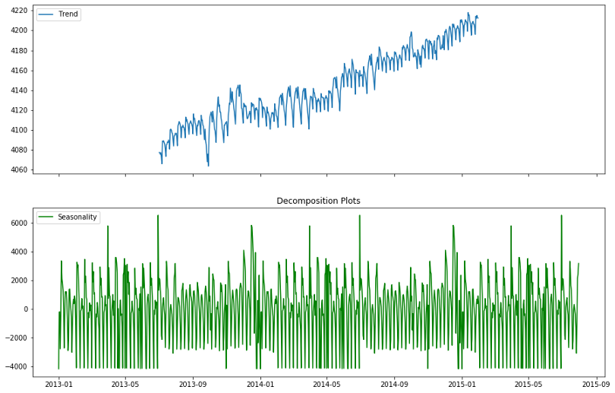

From the above plots, we can see that there are seasonality and trend present in our data. So, we’ll use the forecasting models that take both of these factors into consideration.

**Part B) Forecasting: Predictive Modelling**

1. **Evaluation Metrics**

There are two popular metrics used in measuring the performance of regression (continuous variable) models i.e MAE & RMSE.

**Mean Absolute Error (MAE)**: It is the average of the absolute difference between the predicted values and observed values.

**Root Mean Square Error (RMSE)**: It is the square root of the average of squared differences between the predicted values and observed values.

MAE is easier to understand and interpret but RMSE works well in situations where large errors are undesirable. This is because the errors are squared before they are averaged, thus penalizing large errors. In our case, RMSE suits well because we want to predict the sales with minimum error (i.e penalize high errors) so that inventory can be managed properly.

So, we’ll choose RMSE as a metric to measure the performance of our models.

**2. Predictive Modelling**

**Model 1: Autoregressive Integrated Moving Average (ARIMA)**

We will use one of the most commonly used methods for time-series forecasting, known as ARIMA.

ARIMA models are denoted by ARIMA(p, d, q).

p, d, and q represent seasonality, trend, and noise in data respectively. We’ll first create all possible combinations of p, d, and q as follows:

# Define the p, d and q parameters to take any value between 0 and 3  
p = d = q = range(0, 2)# Generate all different combinations of p, q and q triplets  
pdq = list(itertools.product(p, d, q))# Generate all different combinations of seasonal p, q and q triplets  
seasonal_pdq = [(x[0], x[1], x[2], 12) for x in list(itertools.product(p, d, q))]print('Examples of parameter combinations for Seasonal ARIMA: ')  
print('SARIMAX: {} x {}'.format(pdq[1], seasonal_pdq[1]))  
print('SARIMAX: {} x {}'.format(pdq[1], seasonal_pdq[2]))  
print('SARIMAX: {} x {}'.format(pdq[2], seasonal_pdq[3]))  
print('SARIMAX: {} x {}'.format(pdq[2], seasonal_pdq[4]))



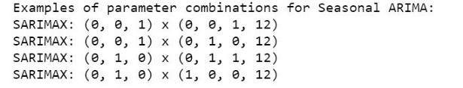

**Hyperparameter tuning for ARIMA**

In order to choose the best combination of the above parameters, we’ll use a **grid search**. The best combination of parameters will give the lowest Akaike information criterion (AIC) score. AIC tells us the quality of statistical models for a given set of data.

# Determing p,d,q combinations with AIC scores.  
for param in pdq:  
 for param_seasonal in seasonal_pdq:  
 try:  
 mod = sm.tsa.statespace.SARIMAX(train_arima,  
 order=param,  
 seasonal_order=param_seasonal,  
 enforce_stationarity=False,  
 enforce_invertibility=False)results = mod.fit()print('ARIMA{}x{}12 - AIC:{}'.format(param, param_seasonal, results.aic))  
 except:  
 continue



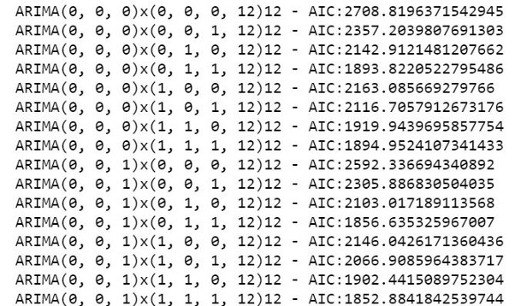

I’ve only included a snapshot of how the grid search looks. The above iteration suggested that **SARIMAX(1, 1, 1)x(0, 1, 1, 12)12** is the best parameter combination with the lowest **AIC: 1806.29.**

**Fitting the ARIMA model**

# Fitting the data to ARIMA model   
model_sarima = sm.tsa.statespace.SARIMAX(train_arima,  
 order=(1, 1, 1),  
 seasonal_order=(0, 1, 1, 12),  
 enforce_stationarity=False,  
 enforce_invertibility=False)results_sarima = model_sarima.fit()print(results_sarima.summary().tables[1])



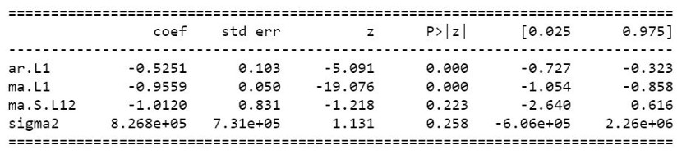

Let’s check diagnostic plots to visualize the performance of our model.

# Checking diagnostic plots  
results_sarima.plot_diagnostics(figsize=(10, 10))  
plt.show()



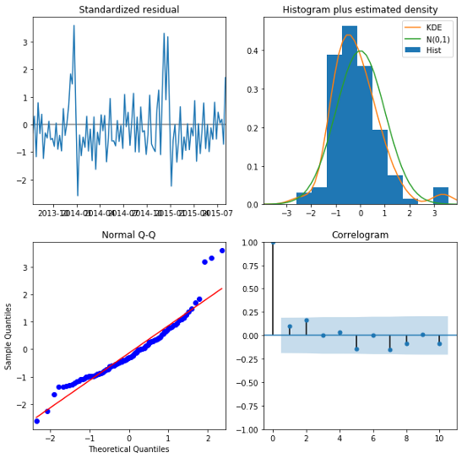

The Normal Q-Q plot shows that the ordered distribution of residuals follows the distribution similar to normal distribution. Thus, our model seems to be pretty good.

**Model Prediction**

# Model Prediction  
# Predictions are performed for the 11th Jan' 2015 onwards of the train data.pred = results_sarima.get_prediction(start=pd.to_datetime('2015-01-11'), dynamic = False)# Get confidence intervals of forecasts  
pred_ci = pred.conf_int()ax = train_arima["2014":].plot(label = "observed", figsize=(15, 7))  
pred.predicted_mean.plot(ax = ax, label = "One-step ahead Forecast", alpha = 1)  
ax.fill_between(pred_ci.index,   
 pred_ci.iloc[:, 0],   
 pred_ci.iloc[:, 1],   
 color = "k", alpha = 0.05)ax.set_xlabel("Date")  
ax.set_ylabel("Sales")plt.legend  
plt.show()train_arima_forecasted = pred.predicted_mean  
train_arima_truth = train_arima["2015-01-11":]# Calculating the error  
rms_arima = sqrt(mean_squared_error(train_arima_truth, train_arima_forecasted))  
print("Root Mean Squared Error: ", rms_arima)



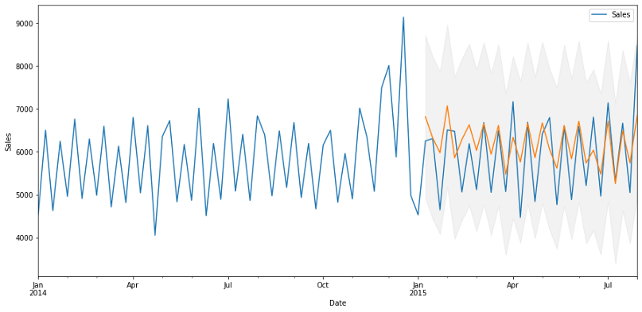





The above plot shows that our predicted values catch up to the observed values in the dataset. Our forecasts seem to align with the ground truth very well and show a spike in December as expected. RMSE is also reasonably low in our case.

So, final ARIMA model can be represented as **SARIMAX(1, 1, 1)x(0, 1, 1, 12)12.**This is the best we can do with ARIMA, so let’s try another model to see whether we can decrease the RMSE.

**Model 2: Prophet**

Prophet is an open-source tool by Facebook. This procedure is used for forecasting time series data based on an additive model where non-linear trends are fit with yearly, weekly, and daily seasonality, plus holiday effects.

**Baseline model**

Our baseline (initial) model will use the default parameters. Let’s see how it performs.

# Creating a train dataset  
train_prophet = train.copy()  
train_prophet.reset_index(level=0, inplace=True)# Converting col names to specific names as required by Prophet library  
train_prophet = train_prophet.rename(columns = {'Date': 'ds',  
 'Sales': 'y'})# Downsampling to week because modelling on daily basis takes a lot of time  
ts_week_prophet = train_prophet.set_index("ds").resample("W").sum()



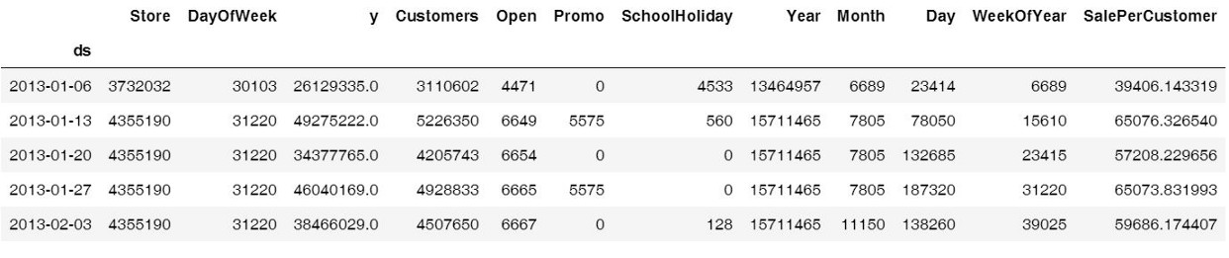

**Fitting the Prophet model**

# Fitting data to Prophet model  
prophet_1 = Prophet()   
prophet_1.fit(ts_week_prophet_train)

**Model Prediction**

future_1 = prophet_1.make_future_dataframe(periods = 52, freq = "W")   
forecast_1 = prophet_1.predict(future)  
forecast_1[["ds", "yhat", "yhat_lower", "yhat_upper"]].tail()



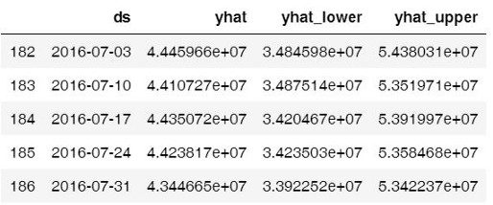

# Visualizing predicions of forecast  
prophet.plot(forecast_1);



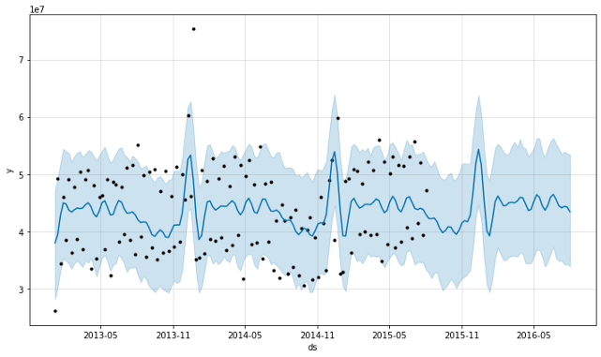

We can see from the above plot that the predictions are decent enough but let’s look at the RMSE to get a better idea.

# Checking the RMSE of Prophet model  
metric_prophet_1 = forecast_1.set_index('ds')[['yhat']].join(ts_week_prophet_train.set_index('ds').y).reset_index()  
metric_prophet_1.dropna(inplace=True)  
rms_prophet_1 = mean_squared_error(metric_prophet_1.y, metric_prophet_1.yhat)  
rms_prophet_1





Wow! RMSE, in this case, is too large and we need to do something about it. Let’s see if we can reduce it by manipulating some of the parameters.

**Hyperparameter tuning for Prophet**

There are a lot of parameters available in the Prophet model. One of the most important ones is **‘holidays’**. This lets us parse holidays explicitly while training the model. We’ll create a new ‘holidays’ data frame by taking observations when there was a school or state holiday.

We’ll also use three more parameters viz.

* **interval_width**: It defines the uncertainty level to make the prediction. The default value is 0.8 but we’ll take 0.95 because we want to be more certain in our predictions.
* **growth**: We know that ‘Sales’ can take any value and there is no saturation point. So, we’ll take ‘linear’ growth instead of ‘logarithmic’.
* **yearly_seasonality**: We’ll explicitly pass it as ‘True’ because we know that there is a yearly seasonality (discussed above) present in our data.

# Encoding state holiday categorical variable  
train_prophet["StateHoliday_cat"] = train_prophet["StateHoliday"].map({0:0, "0": 0, "a": 1, "b": 1, "c": 1})# Choosing only required cols  
train_prophet = train_prophet[['ds', 'y', 'SchoolHoliday', 'StateHoliday_cat']]  
train_prophet.head()



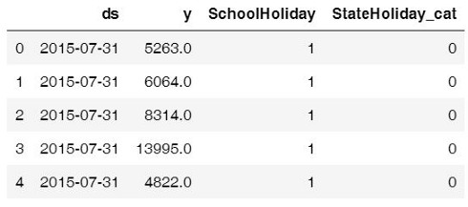

# Modelling holidays - creating holidays dataframe  
state_dates = train_prophet[(train_prophet.StateHoliday_cat == 1)].loc[:, "ds"].values  
school_dates = train_prophet[(train_prophet.SchoolHoliday == 1)].loc[:, "ds"].valuesstate = pd.DataFrame({"holiday": "state_holiday", "ds": pd.to_datetime(state_dates)})  
school = pd.DataFrame({"holiday": "school_holiday", "ds": pd.to_datetime(school_dates)})holidays = pd.concat((state, school))  
holidays.head()# Dropping holiday columns because not needed any more  
train_prophet_clean = train_prophet.drop(["SchoolHoliday", "StateHoliday_cat"], axis = 1)# Downsampling to week because modelling on daily basis takes a lot of time  
ts_week_prophet = train_prophet_clean.set_index("ds").resample("W").sum()# Resetting the index  
ts_week_prophet_train = ts_week_prophet.reset_index()



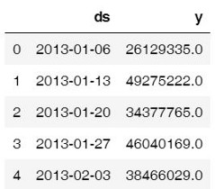

**Fitting the hyper tuned Prophet model**

# Fitting data to Prophet model  
prophet_2 = Prophet(holidays = holidays, interval_width = 0.95, growth='linear', yearly_seasonality = True)   
prophet_2.fit(ts_week_prophet_train)  
print("done")

**Model Prediction**

future_2 = prophet_2.make_future_dataframe(periods = 52, freq = "W")   
forecast_2 = prophet_2.predict(future)  
forecast_2[["ds", "yhat", "yhat_lower", "yhat_upper"]].tail() # We have a new dataframe, which includes, the forecast and the uncertainity invervals.



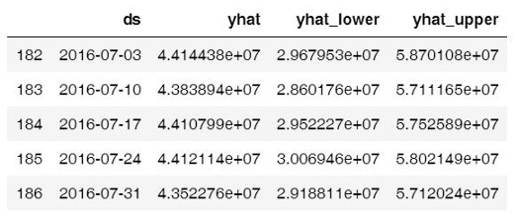

# Visualizing predicions of forecast  
prophet.plot(forecast_2);



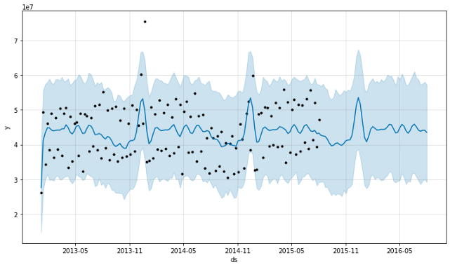

# Visualizing trend and seasonality components  
prophet.plot_components(forecast_2);



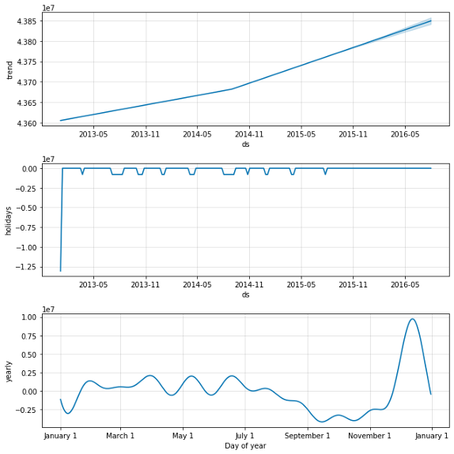

The first plot shows that the total sales on a weekly basis are increasing. The second plot shows the holiday gaps in the dataset and the third plot shows that the store sees very high sales in the last week of December (because of the Christmas holidays).

# Checking the RMSE of Prophet model  
metric_prophet_2 = forecast_2.set_index('ds')[['yhat']].join(ts_week_prophet_train.set_index('ds').y).reset_index()  
metric_prophet_2.dropna(inplace=True)  
rms_prophet_2 = mean_squared_error(metric_prophet_2.y, metric_prophet_2.yhat)  
rms_prophet_2





Our baseline Prophet model used default parameters and we got RMSE of 53782649094881.14 and after hyper tuning, we got RMSE of 52478331938232.15. Although the final model is performing better, it is still performing poorly as compared to ARIMA. So, let’s try another model.

**Model 3: XGBoost**

XGBoost is an optimized distributed gradient boosting library designed to be highly **efficient**, **flexible** and **portable**. Although it is not specifically designed for time-series data, it is known to perform extremely well in all kinds of regression problems.

# Dropping Customers and Sale per customer  
ts_xgboost = train_store_joined.copy()  
ts_xgboost = ts_xgboost.drop(['Customers', 'SalePerCustomer', 'PromoInterval'], axis=1)# Combining similar columns into one column and dropping old columns  
ts_xgboost['CompetitionOpen'] = 12 * (ts_xgboost.Year - ts_xgboost.CompetitionOpenSinceYear) + (ts_xgboost.Month - ts_xgboost.CompetitionOpenSinceMonth)  
ts_xgboost['PromoOpen'] = 12 * (ts_xgboost.Year - ts_xgboost.Promo2SinceYear) + (ts_xgboost.WeekOfYear - ts_xgboost.Promo2SinceWeek) / 4.0  
ts_xgboost = ts_xgboost.drop(["CompetitionOpenSinceMonth", "CompetitionOpenSinceYear"], axis = 1)  
ts_xgboost = ts_xgboost.drop(["Promo2SinceWeek", "Promo2SinceYear"], axis = 1)# Converting categorical cols to numerical cols and removing old cols  
mappings = {0:0, "0": 0, "a": 1, "b": 1, "c": 1}  
ts_xgboost["StateHoliday_cat"] = ts_xgboost["StateHoliday"].map(mappings)  
ts_xgboost["StoreType_cat"] = ts_xgboost["StoreType"].map(mappings)  
ts_xgboost["Assortment_cat"] = ts_xgboost["Assortment"].map(mappings)  
ts_xgboost = ts_xgboost.drop(["StateHoliday", "StoreType", "Assortment"], axis = 1)# Splitting the data  
features = ts_xgboost.drop(["Sales"], axis = 1)  
target = ts_xgboost["Sales"]X_train, X_test, y_train, y_test = model_selection.train_test_split(features, target, test_size = 0.20)

**Baseline Model**

Our baseline (initial) model will use the default parameters. Let’s see how it performs.

# Tuning parameters - using default metrics  
params = {'max_depth':6, "booster": "gbtree", 'eta':0.3, 'objective':'reg:linear'}dtrain = xgb.DMatrix(X_train, y_train)  
dtest = xgb.DMatrix(X_test, y_test)  
watchlist = [(dtrain, 'train'), (dtest, 'eval')]# Training the model  
xgboost = xgb.train(params, dtrain, 100, evals=watchlist,early_stopping_rounds= 100, verbose_eval=True)  
   
# Making predictions  
preds = xgboost.predict(dtest)



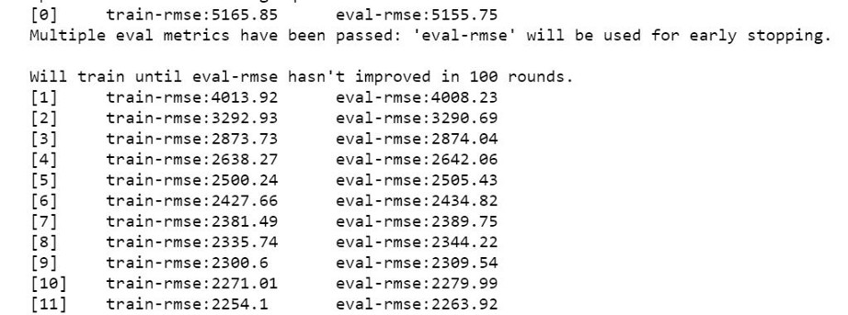

# RMSE of model  
rms_xgboost = sqrt(mean_squared_error(y_test, preds))  
print("Root Mean Squared Error for XGBoost:", rms_xgboost)





It performs pretty well at least in comparison to Prophet. Let’s see if we can further reduce the RMSE.

Hypertuning for XGBoost

Now let’s try to decrease the RMSE of XGBoost by passing different values for our hyperparameters in the XGBoost model.

* **eta**: It defines the learning rate i.e step size to learn the data in the gradient descent modeling (the basis for XGBoost). The default value is 0.3 but we want to keep the learning rate low to avoid overfitting. So, we’ll choose 0.2 as eta.
* **max_depth**: Maximum depth of a tree. The default value is 6 but we want our model to be more complex and find good predictions. So, let’s choose 10 as max depth.
* **gamma**: Minimum loss reduction required to make a further partition on a leaf node of the tree. The larger gamma is, the more conservative the algorithm will be. The default value is 0, let’s choose a little higher value so as to get good predictions.

# Tuning parameters  
params_2 = {'max_depth':10, 'eta':0.1, 'gamma': 2}dtrain = xgb.DMatrix(X_train, y_train)  
dtest = xgb.DMatrix(X_test, y_test)  
watchlist = [(dtrain, 'train'), (dtest, 'eval')]# Training the model  
xgboost_2 = xgb.train(params_2, dtrain, 100, evals=watchlist,early_stopping_rounds= 100, verbose_eval=True)  
   
# Making predictions  
preds_2 = xgboost_2.predict(dtest)



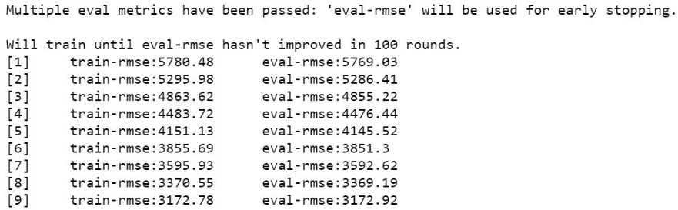

# RMSE of model  
rms_xgboost_2 = sqrt(mean_squared_error(y_test, preds_2))  
print("Root Mean Squared Error for XGBoost:", rms_xgboost_2)





After hyper tuning, we see that our model’s RMSE decreased. Let’s see what features impact the sales of a store.

# Let's see the feature importance  
fig, ax = plt.subplots(figsize=(10,10))  
xgb.plot_importance(xgboost_2, max_num_features=50, height=0.8, ax=ax)  
plt.show()



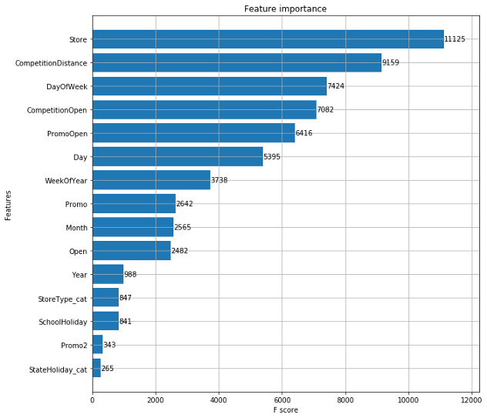

As expected, there are five major reasons affecting the sales of a store viz. the **number of stores, competition distance, day of the week, is the competition open, and promotions**.

Our final XGBoost model after hyper tuning is the one with **‘max_depth’:10, ‘eta’:0.1, ‘gamma’: 2 and RMSE score of 1191.90**, which is great! Now, let's compare the performance of all models

**3. Results**

We used the Root Mean Squared Error (RMSE) to evaluate and validate the performance of various models. Let’s see which model performed better and why/why not.

# Comparing performance of above three models - through RMSE  
rms_arima = format(float(rms_arima))  
rms_prophet_2 = format(float(rms_prophet_2))  
rms_xgboost_2 = format(float(rms_xgboost_2))model_errors = pd.DataFrame({  
 "Model": ["SARIMA", "Prophet", "XGBoost"],  
 "RMSE": [rms_arima, rms_prophet_2, rms_xgboost_2]  
})model_errors.sort_values(by = "RMSE")



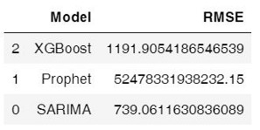

**4. Model Comparison & Selection**

a) We can see from the above table that SARIMA performs the best followed by XGBoost and Prophet.

b) It makes sense because SARIMA is designed specifically for seasonal time series data while XGBoost is a general (though powerful) machine learning approach with various applications.

c) Prophet is a good choice for producing quick forecasts as it doesn’t require strong technical skills. It is easy to implement at scale. The reason for its poor performance here is probably because of a lack of data. It works best with time series that have strong seasonal effects and several seasons of historical data. Prophet is robust to missing data and shifts in the trend, and typically handles outliers well.

Based on the above analysis, we’ll choose ARIMA as our final model to predict the sales because it gives us the least RMSE and is well suited to our needs of predicting time series seasonal data. We chose **ARIMA(1, 1, 1)x(0, 1, 1, 12)12**as the final parameter combination with **AIC of 1806.29 and RMSE of 739.06.**

**5. Conclusion**

**Reflection**

* The most interesting thing about the data was that the category of stores having the highest sales didn’t have the highest sale per customer. It might be because those stores sell small items, which are needed on a daily basis.
* Another interesting thing was that running a promotion for the second time didn’t help in increasing sales. It is probably because customers already purchased whatever they wanted during the first promotional sale.

**Acknowledgments**

<https://machinelearningmastery.com/arima-for-time-series-forecasting-with-python/>

<https://www.digitalocean.com/community/tutorials/a-guide-to-time-series-forecasting-with-arima-in-python-3>

<https://xgboost.readthedocs.io/en/latest/python/python_intro.html>

<https://facebook.github.io/prophet/docs/quick_start.html>

For more details, please check out the source code on **[Github](https://github.com/bisman16/Kaggle_Rossmann_Store_Sales_Forecasting)**.